**Topic Name:**

The main aim of this lab session is to provide hands-on experience on

* Explore file structure
* File management commands
* Absolute path and Relative path
* Globbing
* Scripting

File Structure

1. Under the root directory there are many files like

/bin , /boot , /dev , /etc , ….

Find out the importance of those files

Example : /etc is for user account details

|  |  |  |
| --- | --- | --- |
| **S.No** | **Directory** | **Usage** |
| 1 | / | Root directory |
| 2 | /bin | Binary files |
| 3 | /boot | Files required to boot the system |
| 4 | /dev | Device files |
| 5 | /etc | System configuration files and directories |
| 6 | /home | It’s a personal directory assigned to a user |
| 7 | /lib | contains all helpful library files used by the system |
| 8 | /proc | information about the file systems supported by currently running Linux kernel |
| 9 | /sbin | contains binary executables and command line tools that are preserved for the root user |
| 10 | /tmp | Its stores temporary files |
| 11 | /var | contains data that changes frequently while the system is running. |
| 12 |  |  |
| 13 |  |  |

1. In Linux, there are three different files

Regular file

Directory

Special file

Block file

Character file

Socket file

Pipe file

Fill the below table:

|  |  |  |  |  |  |  |
| --- | --- | --- | --- | --- | --- | --- |
| File Type | Represented by (Hint ls ) | Role | How to create | How to check | Location | Screen shot |
| Regular file | minus(-) | contain common files to store data | touch filename | NA | /home/kali/CYS/vaibhav |  |
| * Text file | minus(-) | contains text data | touch filename.txt | NA | /home/kali/CYS/vaibhav |  |
| * Compressed file | minus(-) | used to compress a file | gzip filename | NA |  |  |
| * Image | minus(-) | contains images | NA | NA | /home/kali/CYS/vaibhav |  |
| Directory | d | contains files and sub directories | mkdir filename | NA | /home/kali/CYS/vaibhav |  |
| Block file | b | represents block device | NA | NA | /dev |  |
| Character file | c | represents character device | NA | NA | /dev |  |
| Socket file | s | provides inter process communication | NA | NA |  |  |
| pipe file | p | Used for Inter process communication | NA | NA | /tmp |  |

1. Globbing
2. Go back to CYS  
   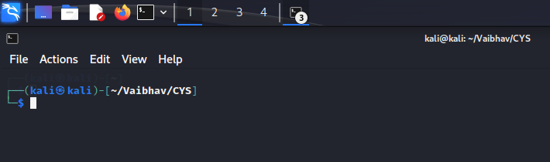
3. Create multiple subdirectories using single command

LS

Unit1

command

glob

Unit2

command

grep

Unit3

constructs

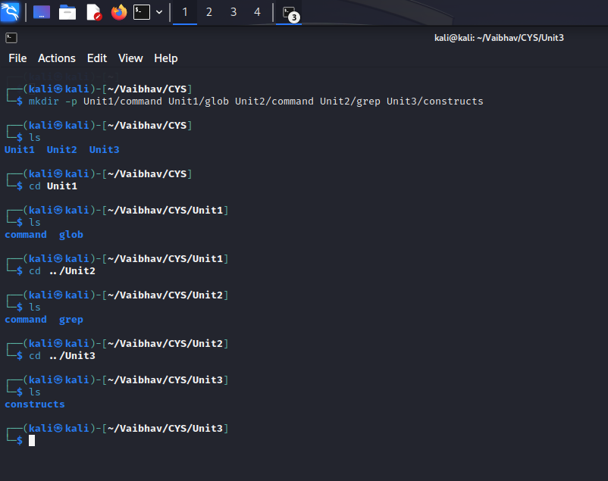

1. Navigate to unit1/glob  
   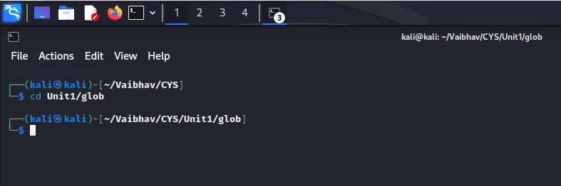
2. Create the following files :

Commands.txt

Commands1.txt

Commands2.txt

page1.html

page2.html

page3.html

file1

file10

file11

file2

File2

File3

file33

fileAB

filea

fileA

fileAAA

file(

file 2  
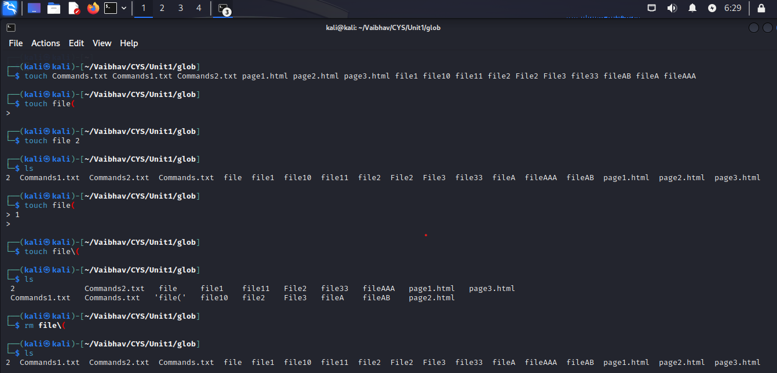  
  
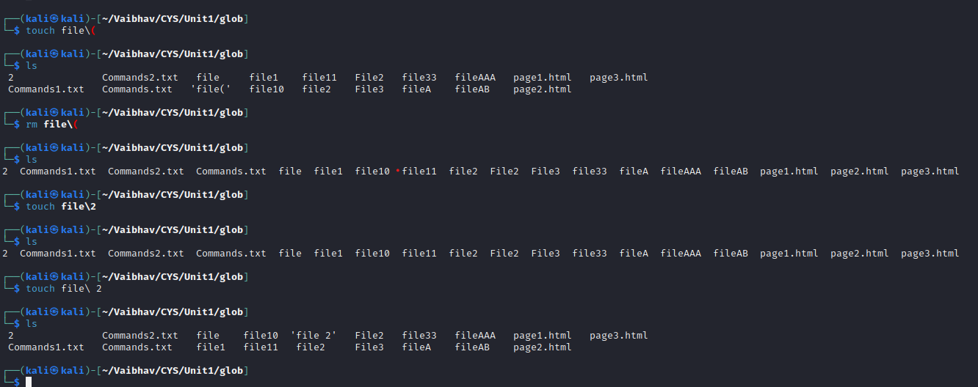

* + 1. List all files starting with file  
       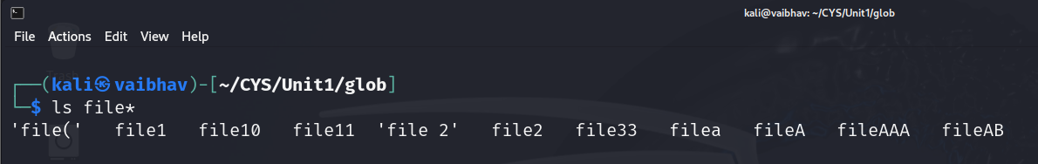
    2. List all files starting with File  
       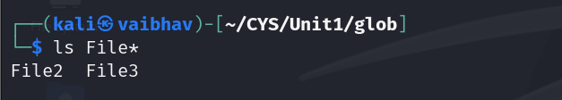
    3. List all files starting with file and ending in a number.  
       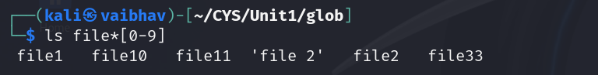
    4. List all files starting with file and ending with a letter  
       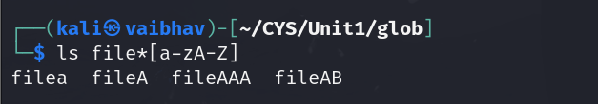
    5. List all files starting with File and having a digit as fifth character.  
       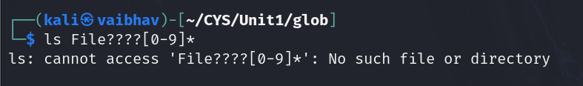
    6. List all files starting with File and having a digit as fifth character and nothing else.  
       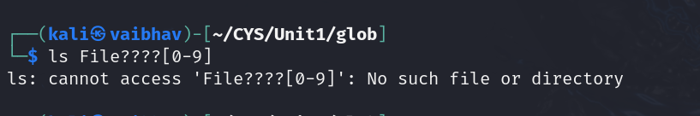
    7. List (with ls) all files starting with a letter and ending in a number.  
       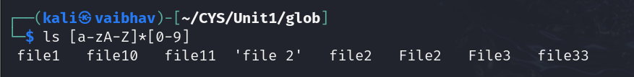
    8. List (with ls) all files that have exactly five characters.  
       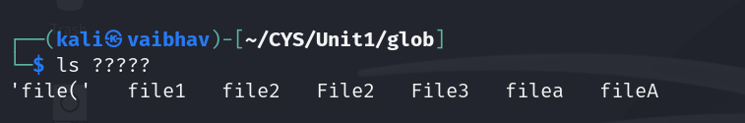
    9. List (with ls) all files that start with f or F and end with 3 or A.  
       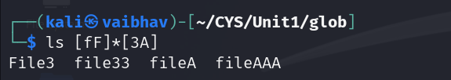
    10. List (with ls) all files that start with f have i or R as second character and end in a number.  
        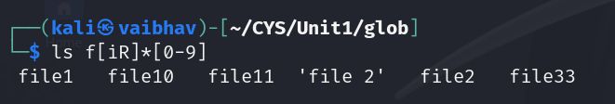
    11. List all files that do not start with the letter F.  
        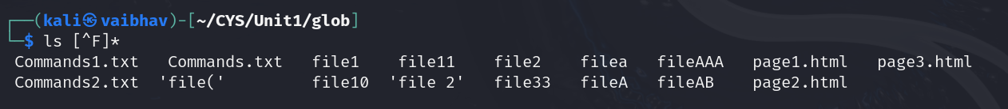
    12. Remove all the *.html   
        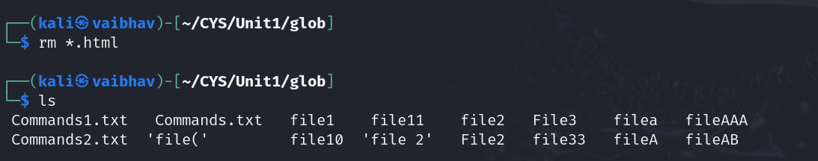
    13. Rename *.txt to *.json   
        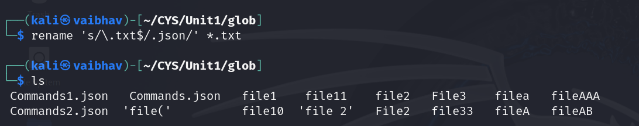

1. Absolute path and relative path

Use rm, mv, cp, ls with absolute path and relative path as per your choice.

1. Wildcards

|  |  |  |  |
| --- | --- | --- | --- |
| Notation | Use | Example | Screenshot |
| * | Matches 0 or more characters | ls file* |  |
| ? | Matches exactly one single character | ls fil?? |  |
| [ ] | Matches a specific pattern defined by sets or ranges | ls file*[a-zA-Z] |  |
| [! ] | Matches any character that is not a member of the set characters | ls [!file]* |  |
| { } | For creating multiple files and directories | mkdir v{1..4} |  |

More on Character class

|  |  |  |  |
| --- | --- | --- | --- |
| Notation | Use | Example | Screenshot |
| [:alnum:] | Matches any alphanumeric character | [0-9a-zA-Z] |  |
| [:alpha:] | Matches any alphabetic character | [a-zA-Z] |  |
| [:digit:] | Matches any digit | [0-9] |  |
| [:lower:] | Matches any lowercase character | [a-z] |  |
| [:upper:] | Matches any uppercase character | [A-Z] |  |

4. change permission

1. Change the permission set of /work/readme.txt so that only the user (owner) can read,write, and execute it. Use absolute mode.  
   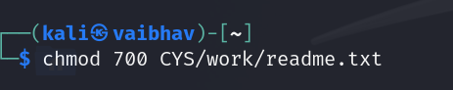
2. Change the permission set of /work/readme.txt so that any user can read it, the group can read/write to it and the user (owner) can read/write/execute it. Use absolute mode.  
   
3. Change the permission set of /bin/bash so that only the user (owner) can read/write/ execute, group, and any user can execute it. However, whenever anyone executes it, it should run with the privileges of the owner user. Use absolute mode.  
   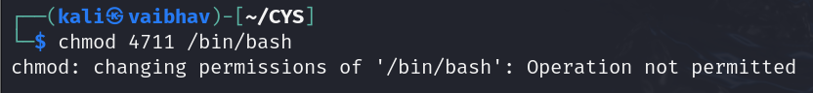
4. Change the permission set of /work/readme.txt so that only the user (owner) can read, write, and execute it. Use relative mode.  
   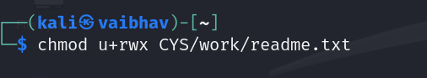
5. Change the permission set of /work/readme.txt so that any user can read it, the group can read/write to it and the user (owner) can read/write/execute it. Use relative mode.  
   
6. Change the permission set of /work/readme.txt so that only the user (owner) can read/write/ execute, group, and any user can execute it. However, whenever anyone executes it, it should run with the privileges of the group. Use absolute mode.  
   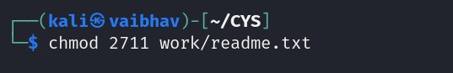
7. Change the permission set of /work/readme.txt so that only the owner can rename or delete this file while maintaining the existing permissions. Use absolute mode.  
   
8. What are the default permissions for the new file?  
   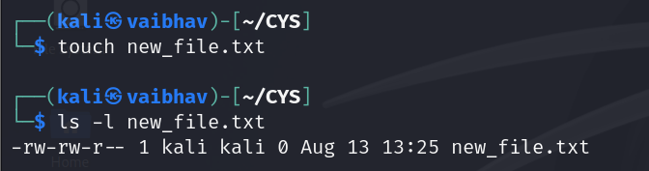
9. What was the command to view the file permissions?  
   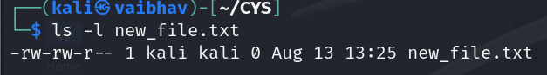
10. Change chmod.exercises permissions to -r--r--r—  
    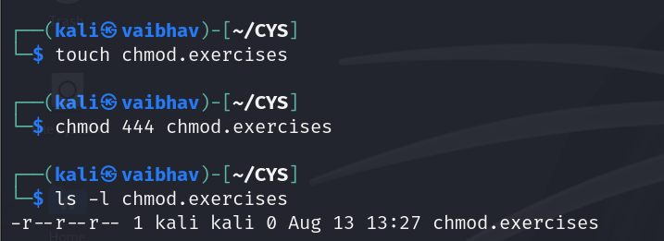
11. Change the file permissions to Read only for the owner, group and all other users.  
    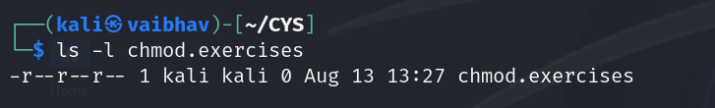
12. What was the command for changing the file permissions to -r--r--r--?  
    
13. Change chmod.exercises permissions to -rw-r-----  
    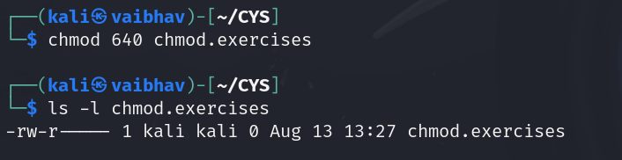
14. Change the file permissions to match the following:
    1. owner: Read and Write
    2. group: Read
    3. other: no permissions (None)  
       
15. What was the command for changing the file permissions to -rw-r-----?  
    
16. Change chmod.exercises permissions to -rwxr-x—x  
    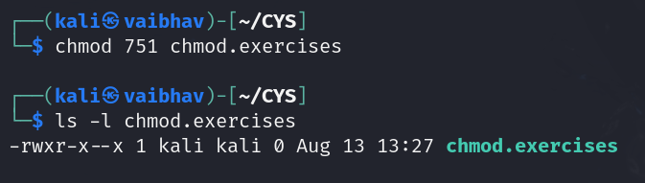
17. Change the file permissions to match the following:
    1. owner: Read, Write and Execute
    2. group: Read and Execute
    3. other: Execute  
       
18. What was the command for changing the file permissions to -rwxr-x--x?  
    

Evaluation :

Marks : 10 (Deadline : 4 – Originality :3 – Completeness :3 )

Deadline: 15.08.2024

In life there are no shortcuts. All things are connected. For success there is no fast lane. Work hard. Focus your energy, practice, remain honest, Truthful, loyal and committed.

-unknown